**JAMSETJI NUSSERWANJI TATA : THE INDUSTRIAL TYCOON**

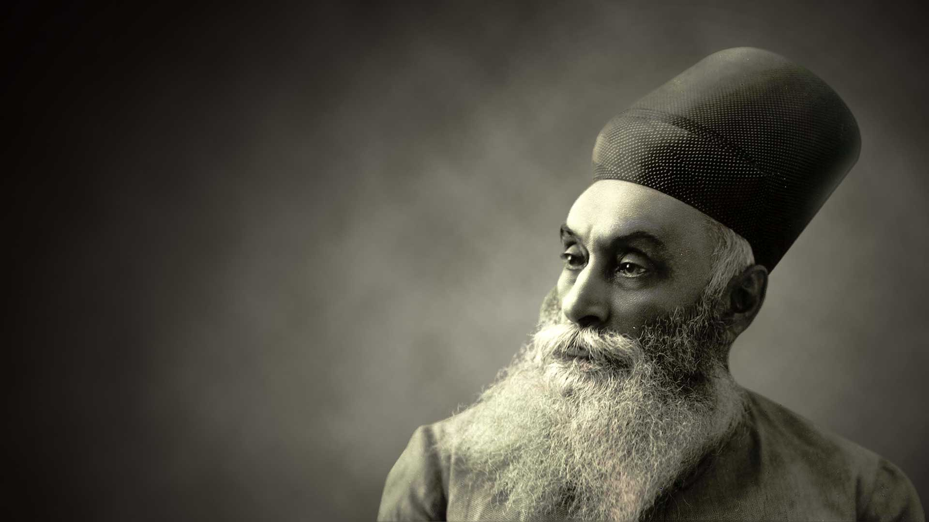

**BACKGROUND**

*“We are a mixed economy. We will remain a mixed economy. The public and private sectors will continue to play a very important role. The private sector in our country has very ample scope and I am confident that India's entrepreneurs have the capacity, and the will to rise to the occasion.”*

*"When you have to give the lead in action, in ideas – a lead which does not fit in with the very climate of opinion – that is true courage, physical or mental or spiritual, call it what you like, and it is this type of courage and vision that Jamshedji Tata showed. It is right that we should honour his memory and remember him as one of the big founders of modern India." —Jawaharlal Nehru for Jamsetji Tata*

*Tata worked in his father's company until he was 29. He founded a trading company in 1868 with ₹21,000 capital (worth US$52 million in 2015 prices). He bought a bankrupt oil mill at Chinchpokli in 1869 and converted it to a cotton mill, which he renamed Alexandra Mill. He sold the mill 2 years later for a profit. Later, in 1874, Jamsetji Tata floated the Central India Spinning, Weaving, and Manufacturing Company in Nagpur because it seemed like a suitable place for him to establish another business venture. Due to this unconventional location, the people of Bombay scorned Tata for not making the smart move by taking the cotton business up in Bombay, known as the "Cottonopolis" of India. They did not understand why he went to the undeveloped city of Nagpur to start a new business.*

**CPI STRATEGY EMPLOYED**

*He was a man of innovation and high intelligence who always believed and said that “With honest and straightforward business principles, close and careful attention to details, and the ability to take advantage of favorable opportunities and circumstances, there is a scope for success.”*

***Collaboration across networks and leading by influence***

*Cotton demand exploded in the 1840s*

*What exactly was Jamsetji tata’s business strategy? How did he build the foundations of the tata group, even during the British raj, most importantly, what are the business lessons that we need to learn from this legendary businessman? This is a story that dates back to 1858 in India. When the British raj had just established itself in India by ending the control of the east India company. During this time, the world was witnessing a textile revolution and the cotton industry was one of the most prosperous industries of all time. At the time, America was one of the largest suppliers of cotton and because of the use of slaves, the Americans were able to produce the cheapest cotton in the world. But just three years down the line in 1861, the American civil war broke out and suddenly the export of American cotton stopped. And because of this, the Britishers began to look toward India for raw materials. Why? Because India had both fertile lands to produce cotton and, naturally strategic seaports to ship it to the world. Therefore, Britain started buying India’s crops under the monopoly of its administration. And because of this scenario, the demand for cotton in India shot up to such an extent that in 1860, India was supplying just 31 % of British cotton imports. But by 1862 this number shot up to 90 % – and this marked the beginning of the cotton revolution in India.*

*This is how he became a leading influence during the British era becoming one of the biggest suppliers of cotton across the globe and creating employment during the time of crisis.*

*Tata’s first venture – Cotton Mill*

*This is when he saw the sequence of events happening in the cotton industry. And in 1869 he did his pilot-type project wherein he bought a bankrupt oil mill in chinchpokli, converted that into a cotton mill, and sold the mill for a profit in just two years. This is when he learned the basics of the cotton industry.*

*He was refused loans for his mill*

*By setting up a high-quality cotton mill that will sell world-class cotton to the world. During that time, Bombay was the first choice to start a cotton mill because of its proximity to the port. But Jamsetji tata had a different plan altogether. And he chose a remote town 800 kms away from Bombay, which is known as Nagpur. Now as soon as everyone in the market came to know about this idea, they laughed at Jamsetji, saying that it was a stupid decision. He was even refused loans because the financier saw no potential in a mill being built in Nagpur as opposed to Bombay. But little did they know that Jamsetji tata knew something that the rest of the traders did not know. And that was the potential of the railways. Because during that time, while railways were relatively new to India in Britain, they had already become the backbone of trade and commerce.*

*Provided medical funds in 1800s*

*And, as it turns out, the people of Nagpur were so far away from the industrial culture of Bombay that most workers did not even consider it important to come to the factory every day. And they used to take leaves even for the smallest reasons. During the initial times, things were so bad that the mill was always working with only 80 % attendance over here. This was the same time when, despite being in our motherland, the Britishers started their atrocities and put- up boards that said- dogs and Indians were not allowed outside the British premises. But this is how ladies and gentlemen Jamsetji Tata decided to deal with this problem. Instead of punishing or scolding the workers, he introduced a provident fund scheme that ensured that every worker would lead a comfortable life after retirement. This was combined with the introduction of medical insurance to help cover the medical costs of workers in case they got injured at work. On top of that, he also introduced family days sports days, and various ceremonies wherein 1000-odd families were rewarded. Gold chains, wrist watches cash, rewards, etc. And all of this was done to develop a bond between the company and the workers such that attendance could be incentivized not so surprisingly, attendance was never a problem after that, and this eventually improved both the profitability and the efficiency of the Empress mill.*

*The biggest Philanthropist world has ever seen!*

*Jamsetji, during his last days, worked very hard to set up a steel plant in India so that India could become a beneficiary of the steel revolution of the world. Apart from that, he also builds the Swadeshi mill as a capitalistic contribution to the independence struggle. Even before the actual Swadeshi movement started. And the most astonishing thing about this wonderful person is that he donated so much of his wealth that, when adjusted for inflation, the value of his donation is* ***$102 billion****, which is even beyond Bill Gates's contribution. – And this makes him the most philanthropic person in the 20th century.*

**DESCRIPTION OF THE CONCEPT AND SOLUTION**

***BRAINSTORMING***



*Brainstorming is a technique by which multiple brains come together and find multiple or a list of solutions to a problem and to enhance the efficiency or an approach to a task or a problem by individuals or a group of them.*

*(Here), Jamsetji Tata alongside his father Nusserwanji Tata strategized to raise employment and business in times when both weren’t prevalent in India*

***DIVERGENT THINKING***

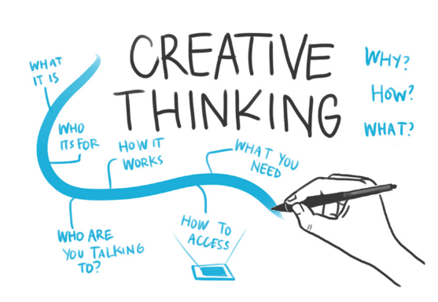

*Divergent Thinking is a thought process used to generate many creative ideas by exploring multiple possible solutions to a problem in a non-linear, spontaneous mode of thinking.*

***FISHBONE DIAGRAM***

*Fish Bone (Ishikawa Diagrams) is a creative way of displaying a problem and/or a solution and doing a comparative study of it in a problem-to-solution-oriented way.*

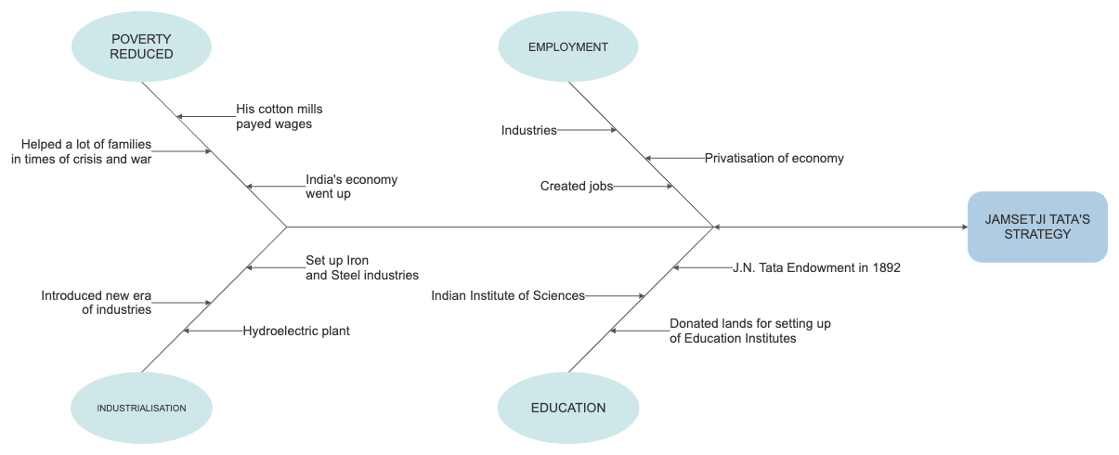

**OUTCOME**



***Creative thinking and Problem-solving goes hand in hand.***

*There exist many problems out there in the world but only a few or a handful number of people are able to approach the problem in certain ways that not only solve the issue but also leave a long-lasting impact on the whole world making it a better place in regard to the problem and it’s the solution.*

**CONCLUSION**



*“Everybody possesses an adequate amount of brain and efficiency to solve problems, all*

*One needs to do is find one out and think through it in ways which are different from*

*The approach that most people follow, here a changemaker takes rise!*

**REFERENCE**

[*https://www.britannica.com/biography/Jamsetji-Nusserwanji-Tata*](https://www.britannica.com/biography/Jamsetji-Nusserwanji-Tata)

[*https://en.wikipedia.org/wiki/Jamsetji_Tata*](https://en.wikipedia.org/wiki/Jamsetji_Tata)

[*https://feedingtrends.com/jamshedji-tatas-strategy-to-build-tata-empire*](https://feedingtrends.com/jamshedji-tatas-strategy-to-build-tata-empire)

**DETAILS OF MEMBERS**

1. *SHIVANG GULATI – 220905264 – CJ 92*
2. *SHANIAA SEN – 220968102 – CJ 60*
3. *AMULYA PARASHAR – 220962046 – CJ 45*
4. *PARTH GHIYA – 220962224 – CJ 82*
5. *NAKUL SINDHWANI – 220933102 – CJ 07*
6. *HARSHIT GARG – 220934050 – CJ 09*